For further information contact our helpline:

**01206 548196**

**Website:** [**www.essexsight.org.uk**](http://www.essexsight.org.uk)

**E-mail: services@essexsight.org.uk**

**Find us on Twitter and Facebook**

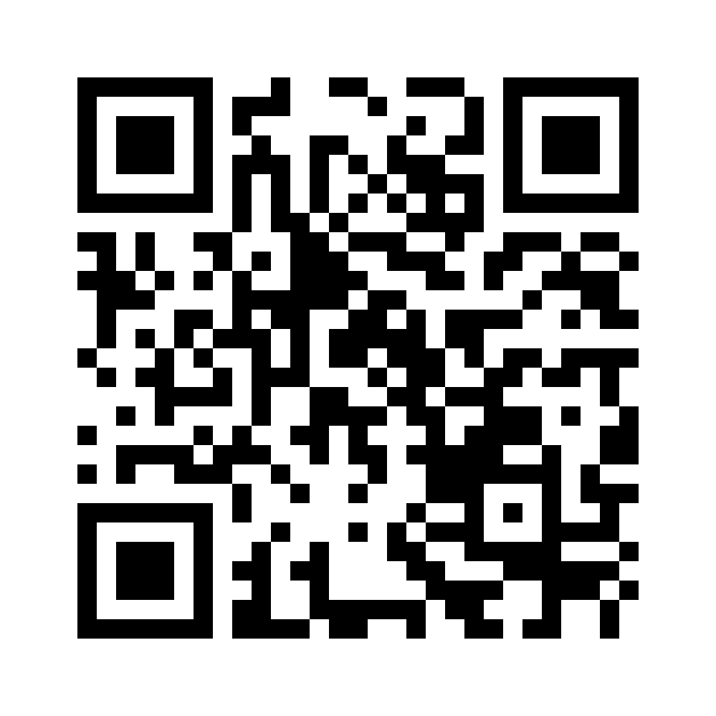**

**Part of Essex Blind Charity**

**Registered Charity No. 1103732**

**Macular Society**

**Contact:**

**Sue   07517 543 948**

**Website: macularsociety.org**

**Visually Impaired?**

**We are here to help**

**FRINTON / WALTON**

**Sight Centre**

**c/o Frinton Macular Society Support Group**

**Frinton Community Association  
Soken House, Triangle Shopping Centre  
Rochford Way, Frinton-on-Sea, CO13 0AU**

**The third Tuesday of each month**

**10am to 12noon**

**The meetings are open to anyone affected by central vision loss. Family, friends and carers welcome.**

**How we can help you**

**Essex Sight provides practical help, emotional support and advice to visually impaired people and their carers**

**We can help people to maintain their safety and independence and reduce their feelings of isolation**

**We can provide information on eye conditions and demonstrate aids and equipment**

**If you would like us to demonstrate a particular piece of equipment, or want specific advice, please let us know in advance so that we can ensure we bring the correct items / information to the centre**

**DATES FOR 2025**

**Tuesday 21st January**

**Tuesday 18th February**

**Tuesday 18th March**

**Tuesday 15th April**

**Tuesday 20th May**

**Tuesday 17th June  
Tuesday 15th July**

**Tuesday 19th August**

**Tuesday 16th September**

**Tuesday 21st October**

**Tuesday 18th November**

**Tuesday 16th December**