Weeley Parish Council

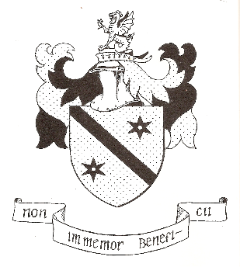

Complaints Procedure
(Adopted December 2022)

Weeley Parish Council is committed to providing a quality service for residents and members of the public who live, work and visit the parish. If you are dissatisfied with the council or a person or body acting on behalf of the Council, this complaints procedure sets out how you may complain to the Council and how we shall try to resolve your complaint in a timely, structured and courteous manner.
How to make a complaint
All formal complaints must be received in writing and made within one month’s notice of the matters which are subject to the complaint. At the outset, you must confirm if you would like the complaint to be treated confidentially. The Council will comply with its obligations under the Data Protection Act 2018 to safeguard against unlawful disclosure of personal data.
Complaints should be sent to:
The Parish Clerk
Weeley Parish Council
64 Queensway,
Holland on Sea,
Clacton on Sea,
CO15 5JU
Or email to: weeleypc@gmail.com
If your complaint concerns the Clerk, it should be sent to the Chairman. (Contact details can be found on the parish website. https://weeleypc.org.uk/
Receipt of the complaint
The Clerk shall acknowledge the complaint in writing within five working days of receipt and inform the complainant of the non-formal and formal options stated below. This will also include contact details of who will be the dealing with the complaint.

Investigation of the complaint
The Council will investigate the facts of the complaint and collate relevant information. A Complaints Committee will be formed from members of the Parish Council.
The complainant shall be invited to attend a meeting where they could make a verbal contribution (and bring along representation of their choice). The meeting will be confidential and closed to the public and members of the press.
Seven clear working days prior to the meeting, the complainant shall provide the Council with copies of any documentation or other evidence regarding the complaint.
The Council shall provide the complainant with copies of any documentation they will present within five working days of the meeting.
Meeting with the complainant (if applicable)
The Chair should introduce everyone and explain how the meeting will proceed.
The complainant should outline the grounds for their complaint and answer any questions from the Complaints Committee.
The Clerk or if the complaint concerns him/her, the Complaint Committee will have the opportunity to explain the Council’s position and questions may be asked by the complainant.
The Clerk, the Complaints Committee and the complainant will be offered the opportunity to summarise their respective positions.
The Clerk or Chair will notify the complainant when a decision about the complaint is likely to be made.
After the complaint has been decided
The complainant will be notified in writing within seven working days of the meeting of whether it has upheld the complaint. The Council will give reasons for its decision together with details of any action to be taken by the Council if this is appropriate.

Kevin Harkin
Parish Clerk

