For further information contact our helpline:
01206 548196

Website: www.essexsight.org.uk
E-mail: services@essexsight.org.uk

Find us on Twitter and Facebook



Part of Essex Blind Charity
Registered Charity No. 1103732
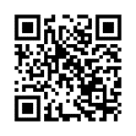


Visually Impaired?
We are here to help
CLACTON
Sight Centre

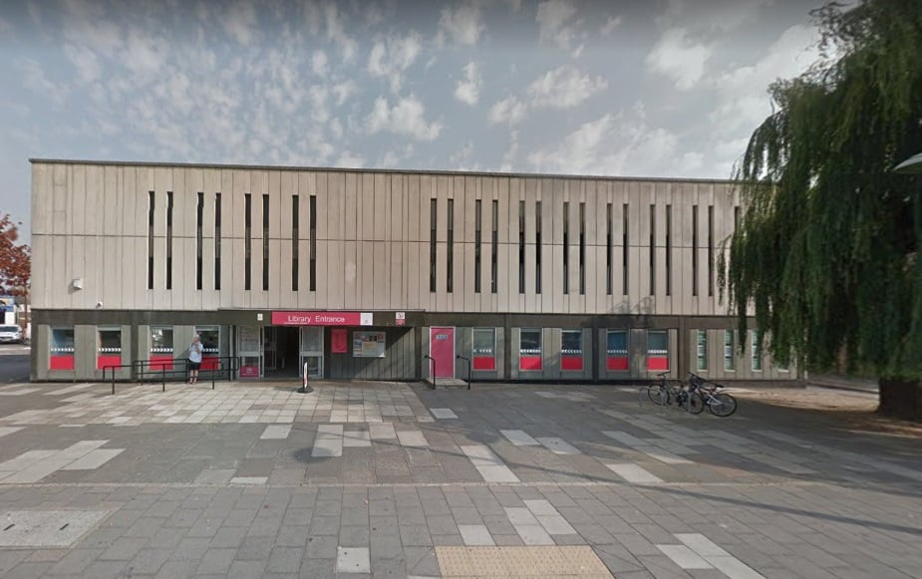

Clacton Library
Station Road
Clacton-on-Sea CO15 1SF

2nd Thursday of each month
1pm – 3pm

Tel 01206 548196 for more information or to make an appointment
How we can help you

Essex Sight provides practical help, emotional support and advice to visually impaired people and their carers

We can help people to maintain their safety and independence and reduce their feelings of isolation

We can provide information on eye conditions and demonstrate aids and small pieces of equipment.

If you would like us to demonstrate a particular piece of equipment, or want specific advice, please let us know in advance so that we can ensure we bring the correct items / information to the centre

DATES FOR 2025

Thursday 9th January
Thursday 13th February
Thursday 13th March
Thursday 10th April
Thursday 8th May
Thursday 12th June
Thursday 10th July
Thursday 14th August
Thursday 11th September
Thursday 9th October
Thursday 13th November
Thursday 11th December

