WIB report Monday 17th March 2025

Hi Steve, below is what we would like to report this month.
Our work at the station has been a little difficult the last couple of weeks as we have been experiencing some vandalism, plants have been taken and thrown around the area including on the train tracks and on top of the metal containers in Pit Stop garage. Also on the up side (Colchester) of the station the wire fence separating the station and Oakliegh Park has been damaged, we do not know if this was vandalism or not. It has been reported to the (BTP) transport police, the issue is that the public can access this onto the station platform.
At the bottom of the street in front of Willow Park care home we had a work party to clear all the brambles:
Before After
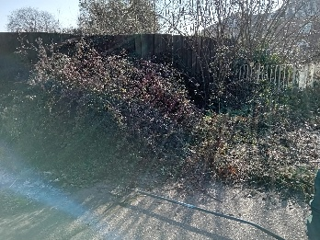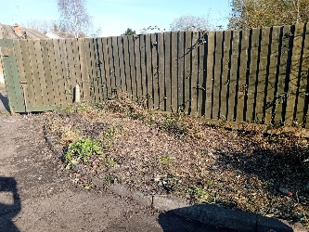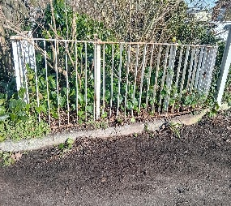

As we were working one of the managers from Willow park came out and thanked us but also warned us to be careful as there has been a lot of sightings of rats, and was unhappy about the water ditch as when there is a heavy rainfall the draining ditch overflows onto the road and underpass causing flooding. Staff from Weeley Bridge caravan park uses a tractor to help clear the water from the road, The reason it floods is because shrubbery has overgrown, therefore the water cannot flow through.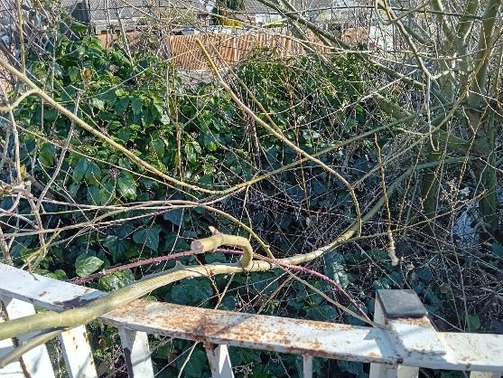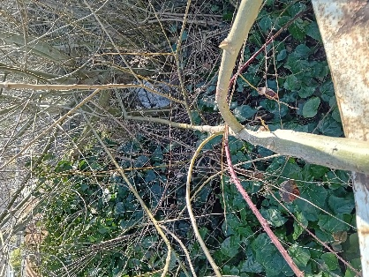
On a happier note, the weather is changing we are getting busier and the village is looking good with the blooming flowers.
As you may have seen the designs for the 200 year train celebrations have begun to go up around the village, all created by Angela Barns. Community rail also put a banner up on the downside of the station.
We had some community involvement as the children from St Andrews school joined us on Friday morning to plant flowers around the statue in second Avenue.

